**Assignment 5**

**MongoDB Restaurant Analysis**

1. Create database – restaurant, create collection – rescollection. Insert the documents into collections.

from pymongo import MongoClient

import json

if __name__ == "__main__":

client = MongoClient("mongodb://localhost:27017")

print(client)

#first create a database

db = client['restaurant']

#collection

collection = db['rescollection']

#loading or opening json file

with open ('C:/Python/restaurants-dataset.json', "r", encoding="utf-8") as file:

record = file.read()

record = record.replace('\n', '')

record = record.replace('}{', '},{')

record = "[" + record + "]"

file_data = json.loads(record)

if isinstance(file_data, list):

collection.insert_many(file_data)

else:

collection.insert_one(file_data)

2.) Display all the documents in the collection restaurants.

db.rescollection.find().pretty()

1. Display the fields restaurant_id, name, borough, and zip code, but exclude the field _id for all the documents in the collection restaurant.

db.rescollection.find({}, {_id:0,restaurant_id:1, name:1, borough:1, zipcode:1})

1. Find the restaurants who achieved a score more than 90.

db.rescollection.find({"grades.score": {$gt:90}}, {name:1})

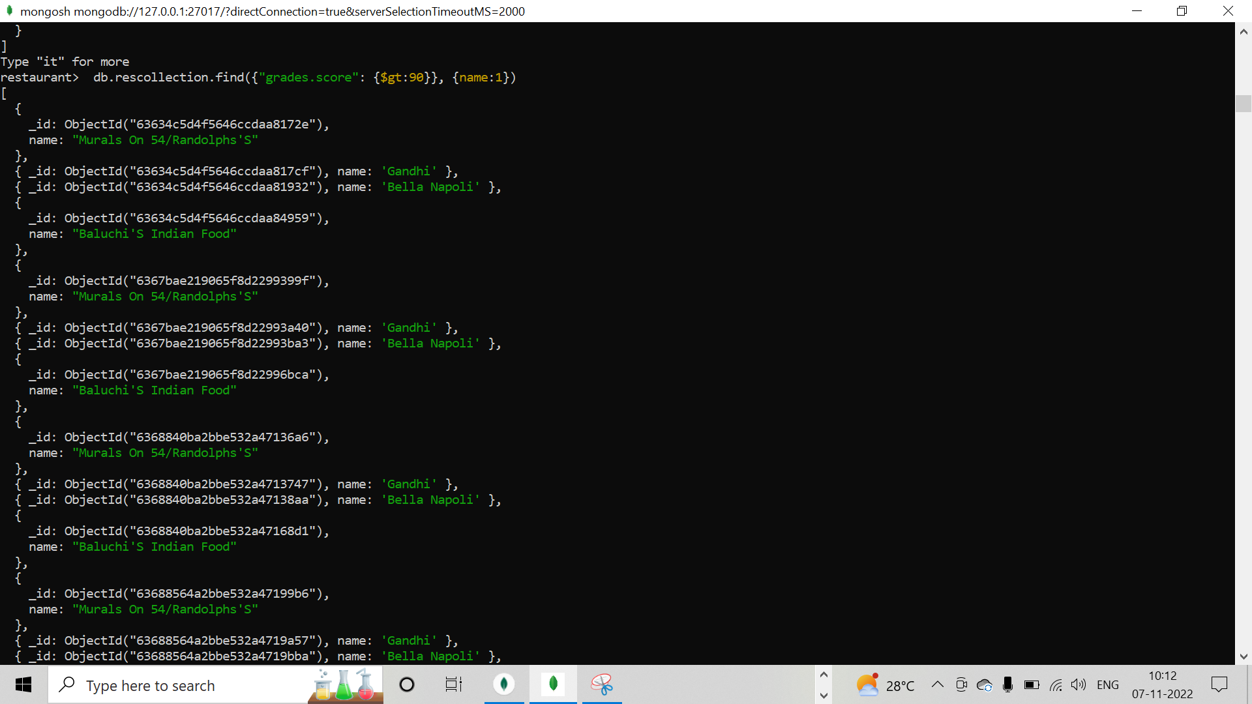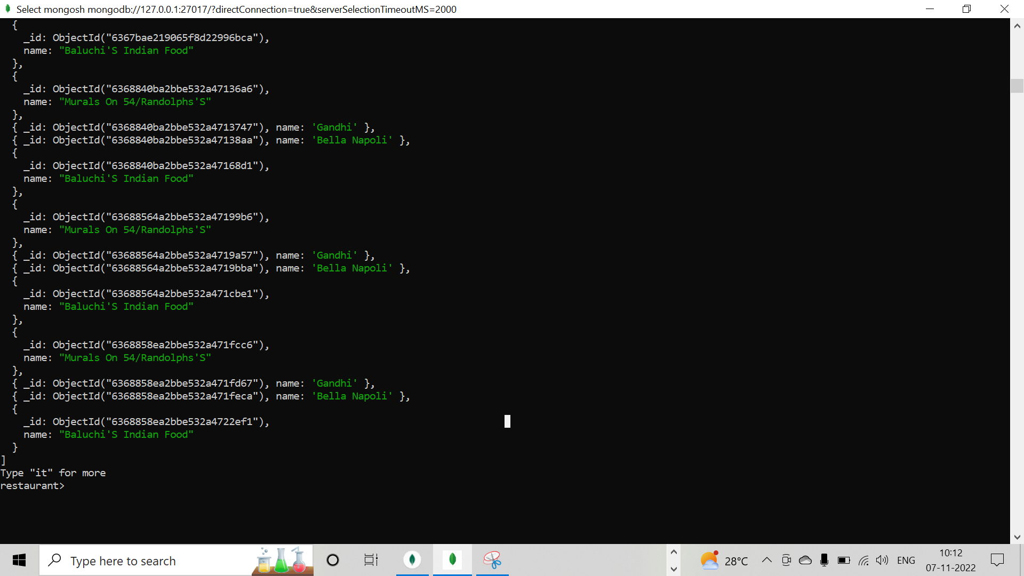

1. Show the restaurants that achieved a score, more than 80 but less than 100.

db.rescollection.find({"grades.score": {$gt : 80 , $lt :100}}, {name:1})

1. Write Query to show the restaurants that do not prepare any cuisine of american & their grade score > 70.

db.rescollection.find({$nor: [{cuisine : 'american'},{'grades.score' : {$gt : 70}}]}, {name:1})

1. Write a MongoDB query to arrange the name of the cuisine in an ascending order and for that same borough arranged in descending order.

db.rescollection.find().sort({cuisine:1, borough:-1})

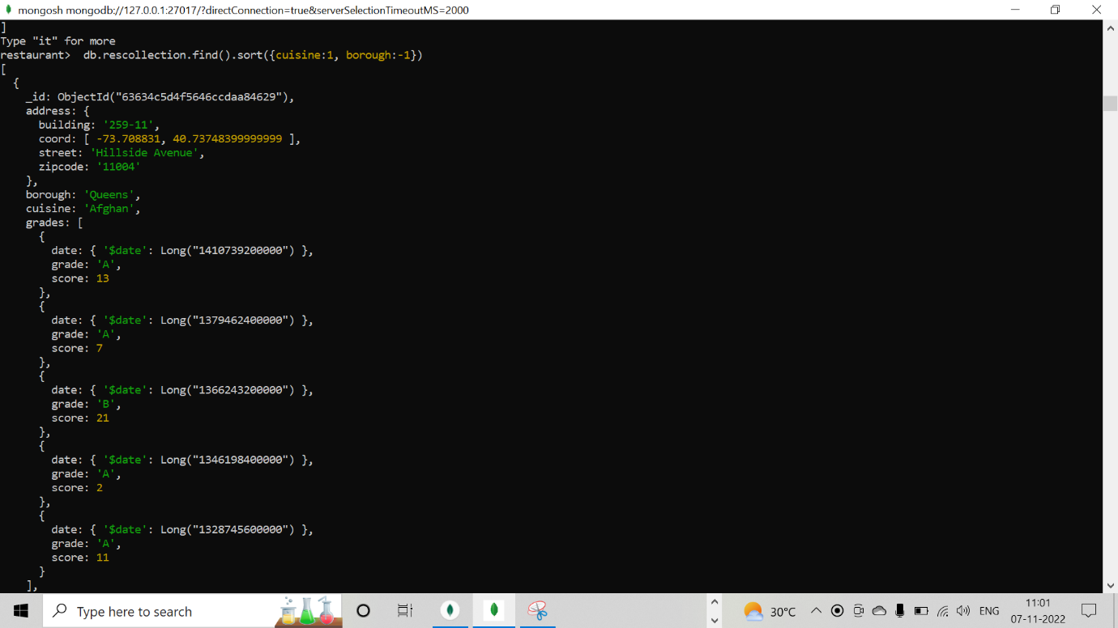

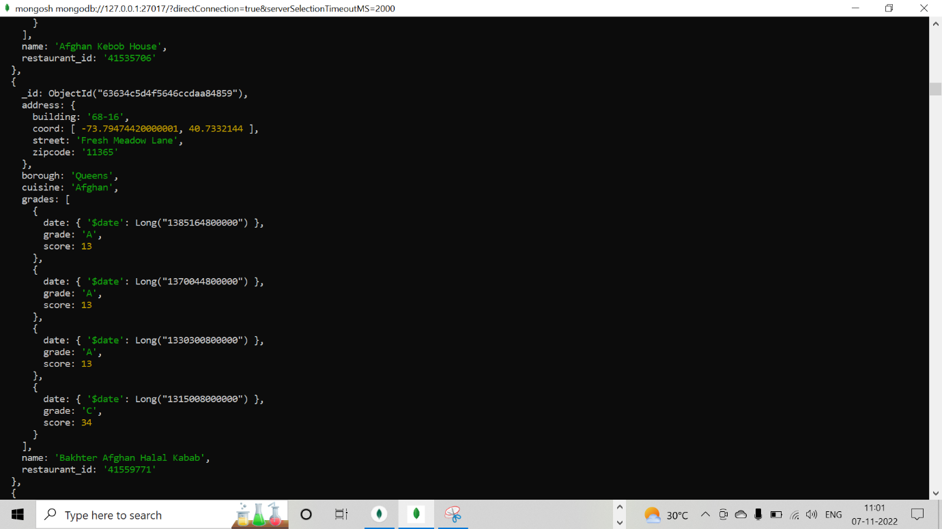

1. Write a MongoDB query to arrange the name of the cuisine in descending order.

db.rescollection.find({},{cuisine : 1}).sort({cuisine:-1})

1. Show the restaurant Id, name, borough and cuisines for those restaurants which prepared dish except 'American' and 'Chinese' or restaurant's name begins with letter 'Bil'.

db.rescollection.find({$or : [{"name" : { $regex : /^Bil.*/}}, {"$and":[{"cuisine":{$ne : "American"}}, {"cuisine": {$ne: "Chinese"}}]}]}, {restaurant_id : 1, name : 1, borough:1, cuisine:1})

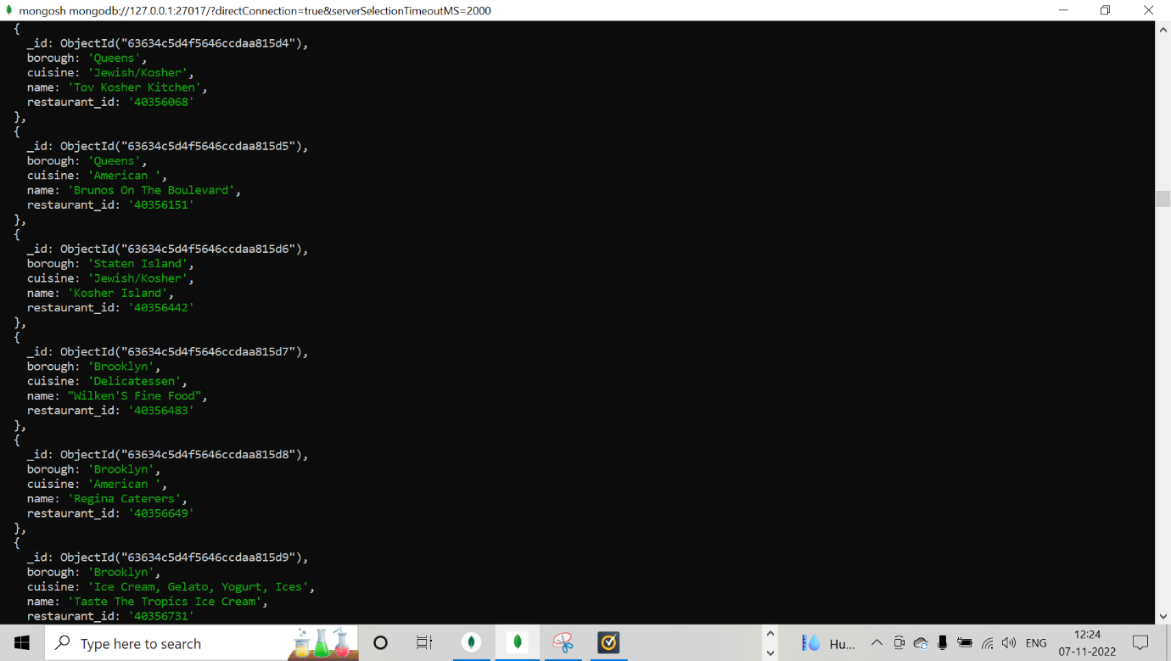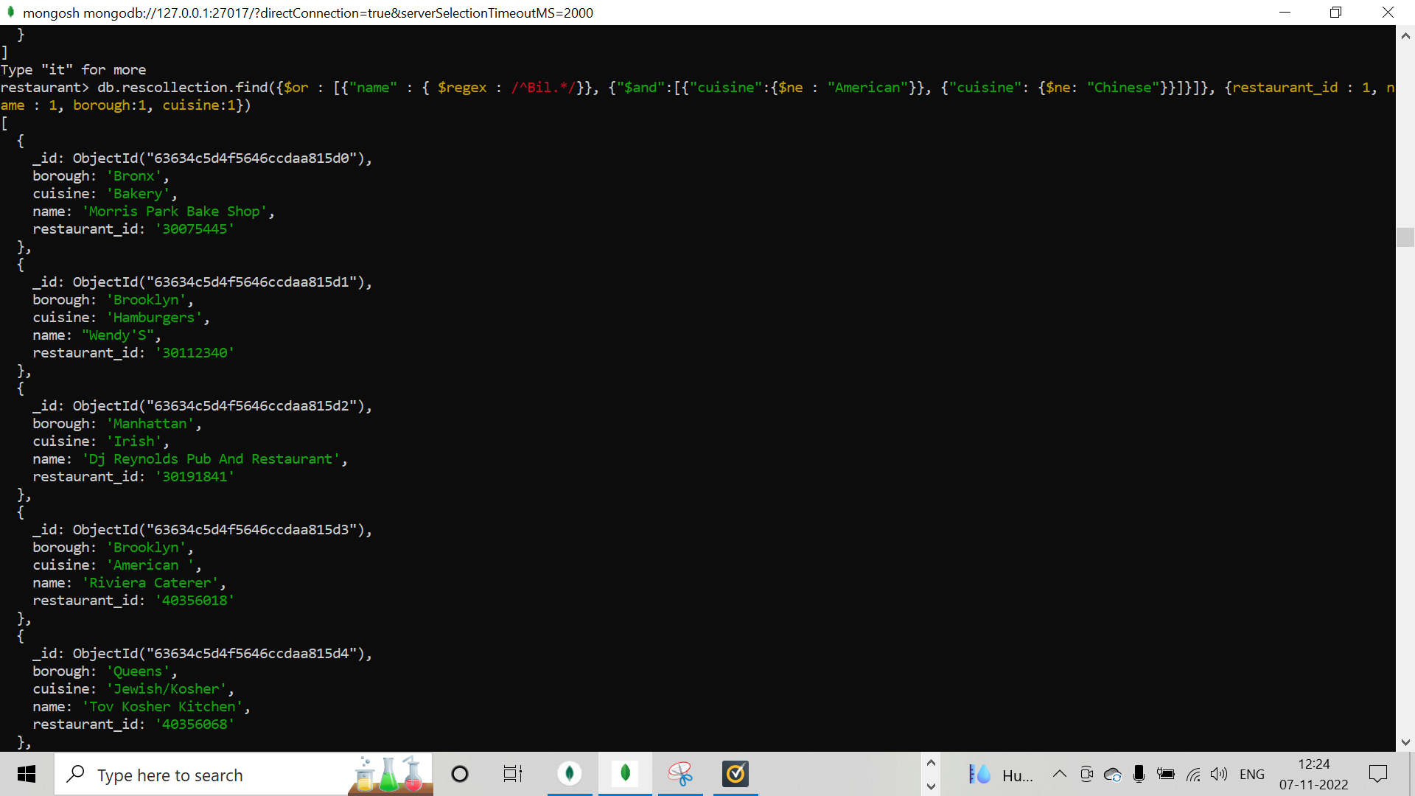

10)  Show the restaurant Id, name, borough and cuisines and score for restaurant's name begins with letter 'Bil'.

db.rescollection.find({"name" : { $regex : /^Bil.*/}}, {restaurant_id : 1, name : 1,borough: 1,'grades.score' :1, cuisine : 1})

11) Show the restaurant Id, name, borough and cuisines and score for restaurant serving “Indian” as cuisines.

db.rescollection.find({cuisine : 'Indian'}, {restaurant_id : 1, name : 1,borough: 1,'grades.score' :1, cuisine : 1})

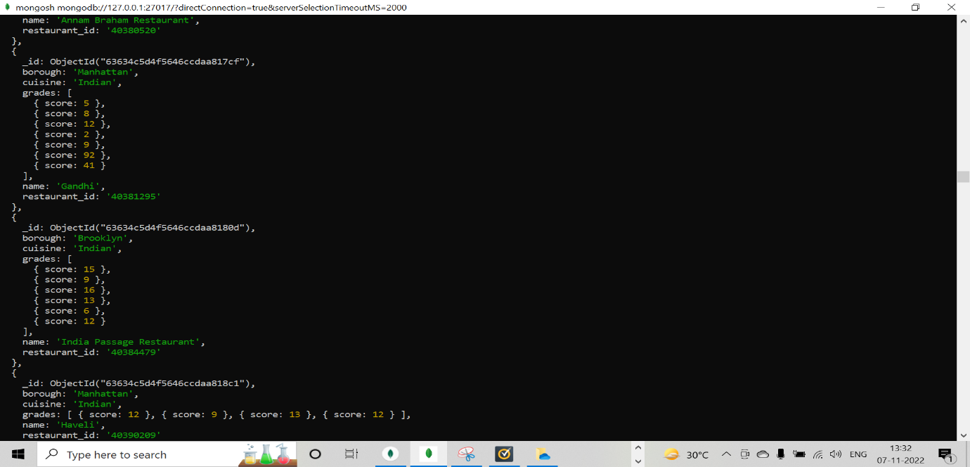

12) Write a MongoDB query to find the restaurant Id, name, borough, cuisines, and score for those restaurants which contain 'bi' as last three letters for its name.

db.rescollection.find({"name" : { $regex : /.*bi$/}}, {restaurant_id : 1, name : 1,borough: 1,'grades.score' :1, cuisine : 1})

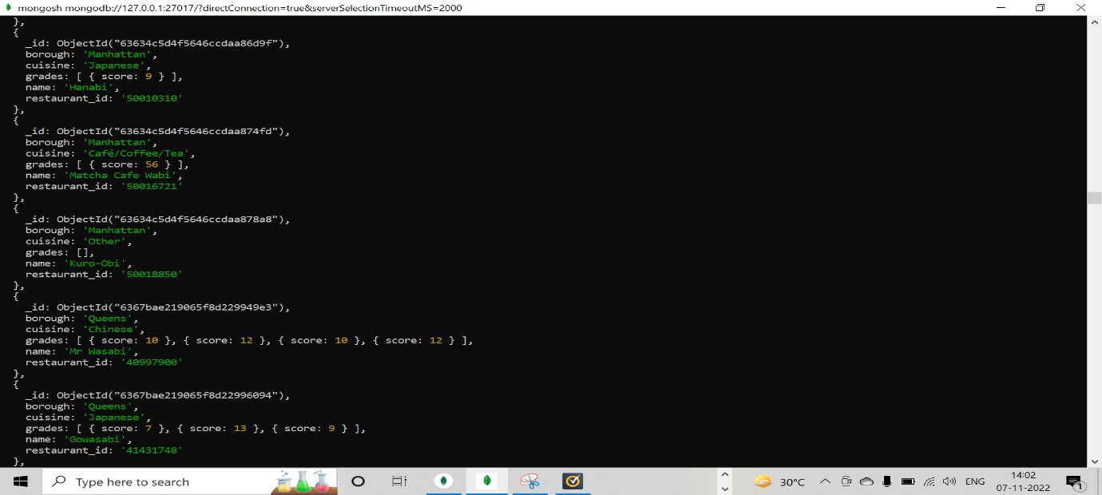

13.) Write a MongoDB query to find the restaurant Id, name, borough, cuisines, and score for those restaurants which contain 'il' as last three letters for its name.

db.rescollection.find({"name" : { $regex : /.*il$/}}, {restaurant_id : 1, name : 1,borough: 1,'grades.score' :1, cuisine : 1})

14.) Write a query to show all the restaurant Id, name, borough, cuisines, and score for those restaurants which contain 'il' anywhere in its name.

db.rescollection.find({"name" : { $regex : /.*il.*/}}, {restaurant_id : 1, name : 1,borough: 1,'grades.score' :1, cuisine : 1})

15.) Write a MongoDB query which will select the restaurant Id, name and grades for those restaurants which returns 0 as a remainder after dividing the score by 7.

db.rescollection.find({"grades.score":{$mod : [7,0]}},{"restaurant_id" : 1,"name":1,"grades":1});

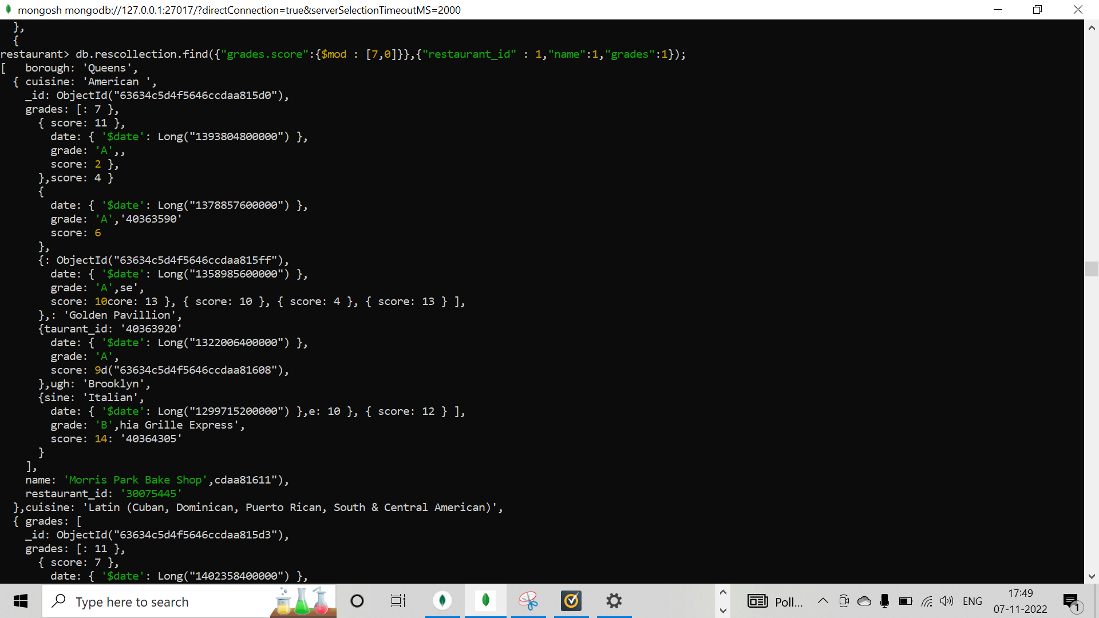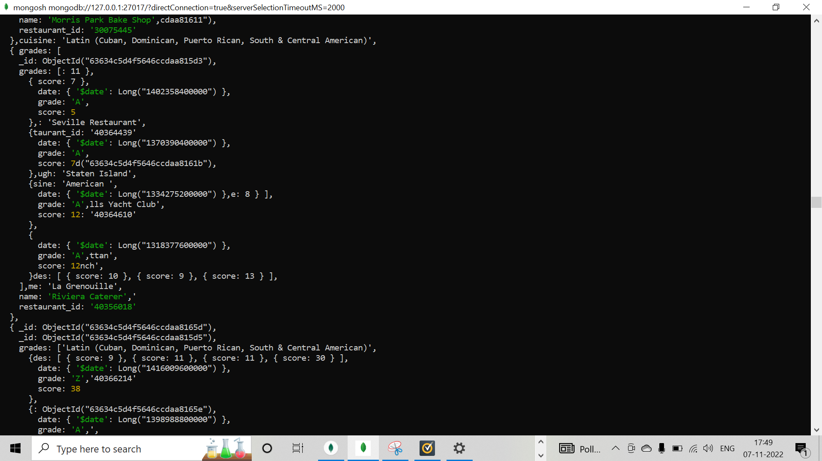

16.) Show document/record counts that has street and not street in addresses.

db.rescollection.find({"address.street":{ $exists : true }});

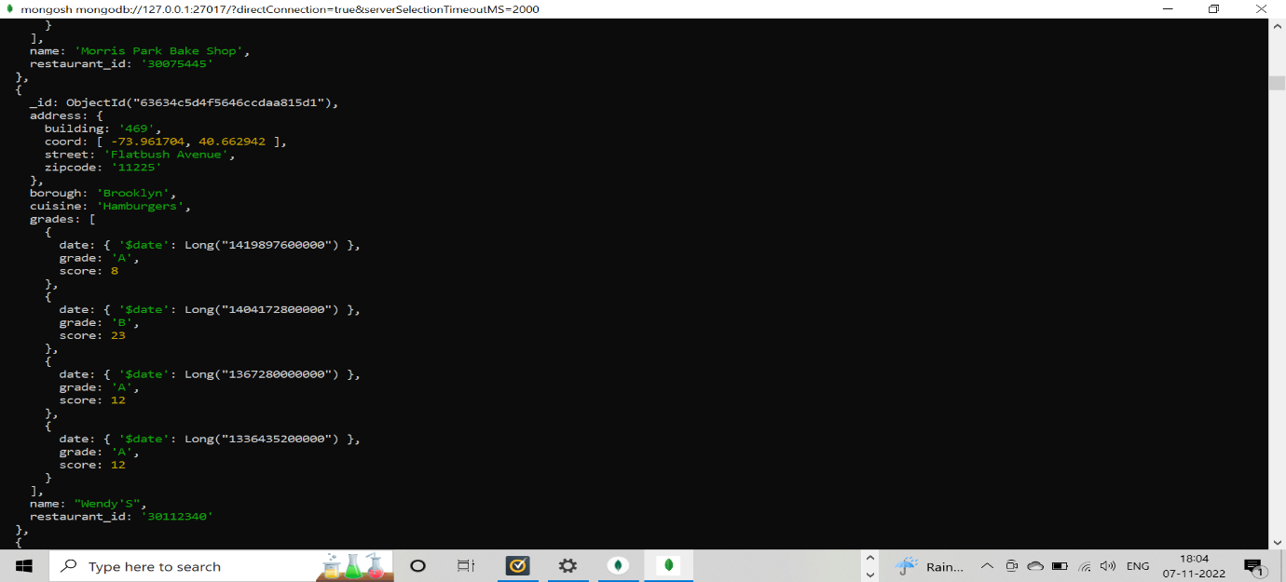

17.) Write a MongoDB query to find the restaurants which do not prepare any cuisine of 'American' and achieved a score more than 70 and located in the longitude less than -65.754168

db.rescollection.find({"cuisine" : {$ne : "American "},"grades.score" :{$gt: 70},"address.coord" : {$lt : -65.754168}});

